JEL Classification:

ARTICLE TITLE

First author FirstName LastName,
Affiliation,
https://orcid.org/0000-0000-0000-00000
e-mail
Second author FirstName LastName,
Affiliation,
https://orcid.org/0000-0000-0000-00000
e-mail
Other author FirstName LastName,

Affiliation,
https://orcid.org/0000-0000-0000-00000
e-mail

Correspondence: e-mail@e-mail.com

Received: dd mmmm yyyy; Accepted: dd mmmm yyyy; Published: dd mmmm yyyy

Abstract. A single paragraph of about 200 words maximum. For research articles, abstracts should give a pertinent overview of the work. We strongly encourage authors to use the following style of structured abstracts, but without headings: (1) Background: Place the question addressed in a broad context and highlight the purpose of the study; (2) Methods: Describe briefly the main methods or treatments applied; (3) Results: Summarize the article's main findings; and (4) Conclusions: Indicate the main conclusions or interpretations. The abstract should be an objective representation of the article, it must not contain results which are not presented and substantiated in the main text and should not exaggerate the main conclusions.
Keywords: human factor, organization, organizational change, resistance, management (5 to 7 words).

Citation: Author 1; Author 2; Author 3. (2024). TITLE. Economics and Finance. http://doi.org/10.51586/xxxxxxx

Introduction
The Introduction should briefly place the study in a broad context and highlight why it is important. It should define the purpose of the work and its significance. The current state of the research field should be reviewed carefully and key publications cited. Please highlight controversial and diverging hypotheses when necessary. Finally, briefly mention the main aim of the work and highlight the principal conclusions. As far as possible, please keep the introduction comprehensible to scientists outside your particular field of research. References should be cited as (Avery et. al., 2006; Buller, 2012), (Feistauer & Richter, 2016), (Boysen and Kelly, 2014), (Gilovich et. al., 2002) or Gilovich et al. (2002). See the end of the document for further details on references.

Literature Review
For Literature Reviews as well as theoretical and methodological articles, also clearly state the reasons that the reported content is important and how the article fits into the cumulative understanding of the field.

Methods
Methods should be described with sufficient details to allow others to replicate and build on published results. Please note that publication of your manuscript implicates that you must make all materials, data, computer code, and protocols associated with the publication available to readers. Please disclose at the submission stage any restrictions on the availability of materials or information. New methods and protocols should be described in detail while well-established methods can be briefly described and appropriately cited.

Results
This section may be divided by subheadings. It should provide a concise and precise description of the experimental results, their interpretation as well as the experimental conclusions that can be drawn.
3.1. Subsection
Bulleted lists look like this:
- First item
- Second item
- Third item

Numbered lists can be added as follows:
- First item
- Second item
- Third item

The text continues here.

Here is an example.
Table 1. Table Title on the Inside
Company | Name | Date
ABC | A Name | 01.08.2016
DEF | B Corp. | 01.08.2017
GHI | C. Name | 01.08.2018
WXY | D. Inc. | 01.08.2019

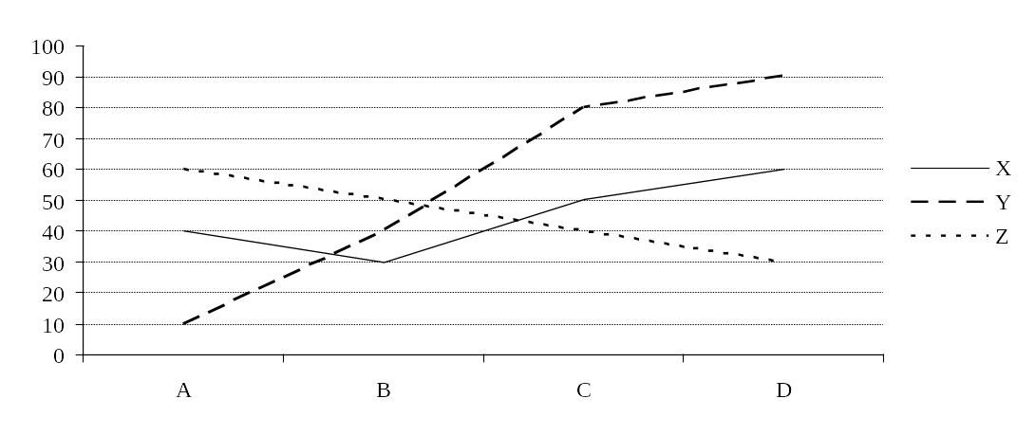
Figure 1. Sample line chart (in %)
Source: Eurostat

3.2. Formatting of Mathematical Components
This is an example of an equation:
, | (1)

the text following an equation need not be a new paragraph. Please punctuate equations as regular text.
Theorem-type environments (including propositions, lemmas, corollaries etc.) can be formatted as follows:

Theorem 1. Example text of a theorem. Theorems, propositions, lemmas, etc. should be numbered sequentially (i.e., Proposition 2 follows Theorem 1). Examples or Remarks use the same formatting, but should be numbered separately, so a document may contain Theorem 1, Remark 1 and Example 1.
The text continues here. Proofs must be formatted as follows:

Proof of Theorem 1. Text of the proof. Note that the phrase ‘of Theorem 1’ is optional if it is clear which theorem is being referred to. Always finish a proof with the following symbol.
The text continues here.

Discussion
Authors should discuss the results and how they can be interpreted in perspective of previous studies and of the working hypotheses. The findings and their implications should be discussed in the broadest context possible. Future research directions may also be highlighted

Conclusion
This section is not mandatory, but can be added to the manuscript if the discussion is unusually long or complex.

Funding: Please add: “This research received no external funding” or “This research was funded by NAME OF FUNDER, grant number XXX” and “The APC was funded by XXX.

Acknowledgments: In this section you can acknowledge any support given which is not covered by the author contribution or funding sections. This may include administrative and technical support, or donations in kind (e.g., materials used for experiments).

Conflicts of Interest: Declare conflicts of interest or state “The authors declare no conflict of interest”. Authors must identify and declare any personal circumstances or interest that may be perceived as inappropriately influencing the representation or interpretation of reported research results. Any role of the funders in the design of the study; in the collection, analyses or interpretation of data; in the writing of the manuscript, or in the decision to publish the results must be declared in this section. If there is no role, please state “The funders had no role in the design of the study; in the collection, analyses, or interpretation of data; in the writing of the manuscript, or in the decision to publish the results”.

References
References should be entitled “References”. Below are some examples of different citations. Place reference in the text enclosing authors’ names and the year of the reference, e.g. “Avery et. al. (2006) points out that…”, “… recent literature (Feistauer & Richter, 2016a, 2016b, 2020, Avery et al., 2006) conclude…”. Note the use of alphabetical order. Include page numbers if appropriate.
https://apastyle.apa.org/style-grammar-guidelines/paper-format/sample-papers

Avery, R. J., Bryant, W. K., Mathios, A., Kang, H., & Bell, D. (2006). Electronic course evaluations: Does an online delivery system influence student evaluations? The Journal of Economic Education, 37(1), 21–37. https://doi.org/10.3200/JECE.37.1.21-37
Berk, R. A. (2012). Top 20 strategies to increase the online response rates of student rating scales. International Journal of Technology in Teaching and Learning, 8(2), 98–107.
Berk, R. A. (2013). Top 10 flashpoints in student ratings and the evaluation of teaching. Stylus.
Boysen, G. A. (2015a). Preventing the overinterpretation of small mean differences in student evaluations of teaching: An evaluation of warning effectiveness. Scholarship of Teaching and Learning in Psychology, 1(4), 269–282. https://doi.org/10.1037/stl0000042
Boysen, G. A. (2015b). Significant interpretation of small mean differences in student evaluations of teaching despite explicit warning to avoid overinterpretation. Scholarship of Teaching and Learning in Psychology, 1(2), 150–162. https://doi.org/10.1037/stl0000017
Boysen, G. A., Kelly, T. J., Raesly, H. N., & Casner, R. W. (2014). The (mis)interpretation of teaching evaluations by college faculty and administrators. Assessment & Evaluation in Higher Education, 39(6), 641–656. https://doi.org/10.1080/02602938.2013.860950
Buller, J. L. (2012). Best practices in faculty evaluation: A practical guide for academic leaders. Jossey-Bass.
Dewar, J. M. (2011). Helping stakeholders understand the limitations of SRT data: Are we doing enough? Journal of Faculty Development, 25(3), 40–44.
Dommeyer, C. J., Baum, P., & Hanna, R. W. (2002). College students’ attitudes toward methods of collecting teaching evaluations: In-class versus on-line. Journal of Education for Business, 78(1), 11–15. https://doi.org/10.1080/08832320209599691
Dommeyer, C. J., Baum, P., Hanna, R. W., & Chapman, K. S. (2004). Gathering faculty teaching evaluations by in-class and online surveys: Their effects on response rates and evaluations. Assessment & Evaluation in Higher Education, 29(5), 611–623. https://doi.org/10.1080/02602930410001689171
Feistauer, D., & Richter, T. (2016). How reliable are students’ evaluations of teaching quality? A variance components approach. Assessment & Evaluation in Higher Education, 42(8), 1263–1279. https://doi.org/10.1080/02602938.2016.1261083
Gilovich, T., Griffin, D., & Kahneman, D. (Eds.). (2002). Heuristics and biases: The psychology of intuitive judgment. Cambridge University Press. https://doi.org/10.1017/CBO9780511808098

Appendix A

The appendix is an optional section that can contain details and data supplemental to the main text. For example, explanations of experimental details that would disrupt the flow of the main text, but nonetheless remain crucial to understanding and reproducing the research shown; figures of replicates for experiments of which representative data is shown in the main text can be added here if brief, or as Supplementary data. Mathematical proofs of results not central to the paper can be added as an appendix.

Appendix B

All appendix sections must be cited in the main text. In the appendixes, Figures, Tables, etc. should be labelled starting with ‘A’, e.g., Figure A1, Figure A2, etc.

 | © 2024 by the authors. Submitted for possible open access publication under  the terms and conditions of the Creative Commons Attribution (CC BY) license https://creativecommons.org/licenses/by/4.0/

